Symmetry Conditions

Definition
# Source: AI Source: Provided by: [Data Path: Persons Table -> ID Column: 1, Name_En Column: Motasem Essam] -> From: [ChatGPT] on [7/25/2026]
Symmetry Conditions are geometric conditions that require a geometric object, figure, or configuration to remain unchanged—or correspond to itself—in a specified way under a symmetry transformation.
A symmetry condition describes a required relationship between an object and its image under a transformation such as:
- reflection,
- rotation,
- point reflection (central symmetry),
- translation,
- glide reflection.
Simple Definition
A Symmetry Condition is a geometric requirement stating that a figure or configuration has a specified symmetry or that two parts of it correspond under a symmetry transformation.
For example, if a figure is symmetric about line $l$, reflection across $l$leaves the figure unchanged.
$$\boxed{R_{l}\left(F\right)=F}$$
where $R_{l}$is reflection across line $l$.

Main Classification
# Source: AI Source: Provided by: [Data Path: Persons Table -> ID Column: 1, Name_En Column: Motasem Essam] -> From: [ChatGPT] on [7/25/2026]
A practical classification of Symmetry Conditions is:
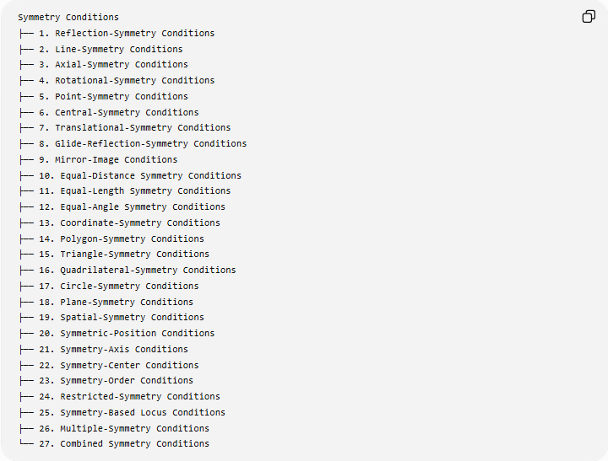
Symmetry Conditions
├── 1. Reflection-Symmetry Conditions
├── 2. Line-Symmetry Conditions
├── 3. Axial-Symmetry Conditions
├── 4. Rotational-Symmetry Conditions
├── 5. Point-Symmetry Conditions
├── 6. Central-Symmetry Conditions
├── 7. Translational-Symmetry Conditions
├── 8. Glide-Reflection-Symmetry Conditions
├── 9. Mirror-Image Conditions
├── 10. Equal-Distance Symmetry Conditions
├── 11. Equal-Length Symmetry Conditions
├── 12. Equal-Angle Symmetry Conditions
├── 13. Coordinate-Symmetry Conditions
├── 14. Polygon-Symmetry Conditions
├── 15. Triangle-Symmetry Conditions
├── 16. Quadrilateral-Symmetry Conditions
├── 17. Circle-Symmetry Conditions
├── 18. Plane-Symmetry Conditions
├── 19. Spatial-Symmetry Conditions
├── 20. Symmetric-Position Conditions
├── 21. Symmetry-Axis Conditions
├── 22. Symmetry-Center Conditions
├── 23. Symmetry-Order Conditions
├── 24. Restricted-Symmetry Conditions
├── 25. Symmetry-Based Locus Conditions
├── 26. Multiple-Symmetry Conditions
└── 27. Combined Symmetry Conditions
Note: This is a practical/descriptive classification. Some categories overlap, and terminology such as line symmetry and axial symmetry is often used interchangeably.

1. Reflection-Symmetry Conditions
# Source: AI Source: Provided by: [Data Path: Persons Table -> ID Column: 1, Name_En Column: Motasem Essam] -> From: [ChatGPT] on [7/25/2026]
Definition
A Reflection-Symmetry Condition requires a figure to coincide with itself after reflection across a specified line or plane.
For a plane figure $F$and reflection $R_{l}$:
$$\boxed{R_{l}\left(F\right)=F}.$$
Example
A square has reflection symmetry across each of its four symmetry axes.
If $l$is one of those axes:
$$R_{l}\left(\text{square}\right)=\text{square}.$$
Important Property
Every point and its reflected image are:
- equally distant from the symmetry axis,
- on opposite sides of the axis,
- connected by a segment perpendicular to the axis.

2. Line-Symmetry Conditions
# Source: AI Source: Provided by: [Data Path: Persons Table -> ID Column: 1, Name_En Column: Motasem Essam] -> From: [ChatGPT] on [7/25/2026]
Definition
A Line-Symmetry Condition requires a line to act as an axis of symmetry for a plane figure.
If $l$is the symmetry axis:
$$\boxed{R_{l}\left(F\right)=F}.$$
Example
For an isosceles triangle, the line from the vertex to the midpoint of the base is a line of symmetry.
It divides the triangle into two congruent mirror-image halves.
Consequences
If $l$is a symmetry axis:
$$PA=PA^{'}$$
where $A^{'}$is the reflection of $A$across $l$.

3. Axial-Symmetry Conditions
# Source: AI Source: Provided by: [Data Path: Persons Table -> ID Column: 1, Name_En Column: Motasem Essam] -> From: [ChatGPT] on [7/25/2026]
Definition
Axial Symmetry is another common term for reflection symmetry about an axis.
The condition is:
$$\boxed{\text{Reflection across axis }l\text{ leaves the figure unchanged}.}$$
Example
A regular polygon has reflection axes.
A regular pentagon has:
$$5$$
reflection axes.
A regular hexagon has:
$$6$$
reflection axes.
For a regular $n$-gon:
$$\boxed{n\text{ reflection axes}}.$$

4. Rotational-Symmetry Conditions
# Source: AI Source: Provided by: [Data Path: Persons Table -> ID Column: 1, Name_En Column: Motasem Essam] -> From: [ChatGPT] on [7/25/2026]
Definition
A Rotational-Symmetry Condition requires a figure to coincide with itself after rotation through a specified non-zero angle.
If $R_{θ}$is rotation through $θ$:
$$\boxed{R_{θ}\left(F\right)=F}.$$
Order of Rotational Symmetry
If the smallest positive rotation that maps the figure onto itself is:
$$θ_{min},$$
then the order is:
$$\boxed{n=\frac{{360}^{∘}}{θ_{min}}}.$$
Example: Square
A square maps onto itself after:
$${90}^{∘}, {180}^{∘}, {270}^{∘}, {360}^{∘}.$$
Therefore its rotational symmetry has order:
$$\boxed{4}.$$

5. Point-Symmetry Conditions
# Source: AI Source: Provided by: [Data Path: Persons Table -> ID Column: 1, Name_En Column: Motasem Essam] -> From: [ChatGPT] on [7/25/2026]
Definition
A Point-Symmetry Condition requires a figure to remain unchanged under a ${180}^{∘}$rotation about a specified point.
If $O$is the center:
$$\boxed{R_{O,{180}^{∘}}\left(F\right)=F}.$$
Example
A parallelogram has point symmetry about the intersection of its diagonals.
If $A^{'}$is the image of $A$, then:
$$O\text{ is the midpoint of }AA^{'}.$$
Important
Point symmetry is equivalent to rotational symmetry of order $2$.

6. Central-Symmetry Conditions
# Source: AI Source: Provided by: [Data Path: Persons Table -> ID Column: 1, Name_En Column: Motasem Essam] -> From: [ChatGPT] on [7/25/2026]
Definition
Central Symmetry is another name for point symmetry in which every point has an opposite corresponding point with the same center midpoint.
For center $O$:
$$\boxed{O\text{ is the midpoint of }PP^{'}}$$
for every corresponding pair $P,P^{'}$.
Equivalently:
$$\vec{OP^{'}}=-\vec{OP}.$$
Example
A parallelogram is centrally symmetric about the intersection of its diagonals.

7. Translational-Symmetry Conditions
# Source: AI Source: Provided by: [Data Path: Persons Table -> ID Column: 1, Name_En Column: Motasem Essam] -> From: [ChatGPT] on [7/25/2026]
Definition
A Translational-Symmetry Condition requires a figure or pattern to reproduce itself after translation by a specified vector.
If $T_{\vec{v}}$is a translation:
$$\boxed{T_{\vec{v}}\left(F\right)=F}.$$
Example
An infinite repeating pattern may satisfy:
$$T_{\vec{v}}\left(F\right)=F.$$
For example, a pattern repeated every $5$units horizontally has translational symmetry:
$$\vec{v}=\left(5 , 0\right).$$
Important Distinction
A finite isolated polygon normally does not have nonzero translational symmetry as a whole, because translating it moves it to a different location.
Translational symmetry is especially natural for:
- infinite patterns,
- tessellations,
- periodic figures,
- repeating structures.

8. Glide-Reflection-Symmetry Conditions
# Source: AI Source: Provided by: [Data Path: Persons Table -> ID Column: 1, Name_En Column: Motasem Essam] -> From: [ChatGPT] on [7/25/2026]
Definition
A Glide-Reflection-Symmetry Condition combines:
- reflection across a line, and
- translation along that same line.
The combined transformation is:
$$\boxed{G=T_{\vec{v}}∘R_{l}}.$$
A pattern has glide-reflection symmetry if:
$$\boxed{G\left(F\right)=F}.$$
Example
Some repeating frieze patterns remain unchanged after reflecting across a horizontal axis and then translating along that axis.

9. Mirror-Image Conditions
# Source: AI Source: Provided by: [Data Path: Persons Table -> ID Column: 1, Name_En Column: Motasem Essam] -> From: [ChatGPT] on [7/25/2026]
Definition
A Mirror-Image Condition requires two objects or regions to be reflections of each other across a specified line or plane.
If $A^{'}$is the mirror image of $A$:
$$A^{'}=R_{l}\left(A\right).$$
Example
If two points $A$and $A^{'}$are mirror images across $l$, then:
$$AA^{'}⊥l$$
and $l$bisects $AA^{'}$.
Thus:
$$d\left(A , l\right)=d\left(A^{'} , l\right).$$

10. Equal-Distance Symmetry Conditions
# Source: AI Source: Provided by: [Data Path: Persons Table -> ID Column: 1, Name_En Column: Motasem Essam] -> From: [ChatGPT] on [7/25/2026]
Definition
A symmetry condition may require corresponding points to be equally distant from a symmetry axis or center.
For reflection symmetry:
$$\boxed{PA=PA^{'}}$$
when $P$lies on the symmetry axis.
Example
If $A^{'}$is the reflection of $A$across line $l$, then every point $P∈l$satisfies:
$$PA=PA^{'}.$$
This connects symmetry with the perpendicular bisector locus.

11. Equal-Length Symmetry Conditions
# Source: AI Source: Provided by: [Data Path: Persons Table -> ID Column: 1, Name_En Column: Motasem Essam] -> From: [ChatGPT] on [7/25/2026]
Symmetry often produces corresponding equal lengths.
Example
In an isosceles triangle:
$$AB=AC.$$
The equality reflects the symmetry of the triangle about the altitude from $A$.
Important
Equal lengths alone do not always prove symmetry. Additional geometric conditions may be necessary.
For example:
$$AB=AC$$
is enough to establish the standard symmetry of an isosceles triangle, but arbitrary equal-length segments in a general figure do not automatically establish a global symmetry.

12. Equal-Angle Symmetry Conditions
# Source: AI Source: Provided by: [Data Path: Persons Table -> ID Column: 1, Name_En Column: Motasem Essam] -> From: [ChatGPT] on [7/25/2026]
Symmetry can produce pairs of equal angles.
Example
In an isosceles triangle:
$$∠B=∠C.$$
The equality results from reflection symmetry.
Reflection Principle
Reflection preserves angle measure:
$$\boxed{m∠A=m∠A^{'}}.$$

13. Coordinate-Symmetry Conditions
# Source: AI Source: Provided by: [Data Path: Persons Table -> ID Column: 1, Name_En Column: Motasem Essam] -> From: [ChatGPT] on [7/25/2026]
Symmetry can be expressed algebraically in a coordinate system.
Symmetry About the $x$-Axis
If:
$$\left(x , y\right)$$
belongs to a figure, then:
$$\left(x , -y\right)$$
must also belong to it.
Example
$$x^{2}+y^{2}=25$$
is symmetric about the $x$-axis because replacing $y$with $-y$gives:
$$x^{2}+{\left(-y\right)}^{2}=x^{2}+y^{2}=25.$$
Symmetry About the $y$-Axis
Replace:
$$x→-x.$$
Symmetry About the Origin
Replace:
$$\left(x , y\right)→\left(- , x-y\right).$$

14. Function-Based Symmetry Conditions
# Source: AI Source: Provided by: [Data Path: Persons Table -> ID Column: 1, Name_En Column: Motasem Essam] -> From: [ChatGPT] on [7/25/2026]
For a function $y=f\left(x\right)$:
Even Function
If:
$$\boxed{f\left(-x\right)=f\left(x\right)},$$
the graph is symmetric about the $y$-axis.
Odd Function
If:
$$\boxed{f\left(-x\right)=-f\left(x\right)},$$
the graph has point symmetry about the origin.
Example
$$f\left(x\right)=x^{2}$$
is even:
$$f\left(-x\right)={\left(-x\right)}^{2}=x^{2}=f\left(x\right).$$
Therefore its graph is symmetric about the $y$-axis.

15. Polygon-Symmetry Conditions
# Source: AI Source: Provided by: [Data Path: Persons Table -> ID Column: 1, Name_En Column: Motasem Essam] -> From: [ChatGPT] on [7/25/2026]
Polygons can possess reflection symmetry, rotational symmetry, or both.
Regular Polygon
A regular $n$-gon has:
$$\boxed{n\text{ reflection axes}}$$
and rotational symmetry of order:
$$\boxed{n}.$$
Examples
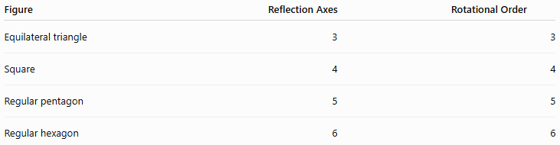
Figure | Reflection Axes | Rotational Order
Equilateral triangle | 3 | 3
Square | 4 | 4
Regular pentagon | 5 | 5
Regular hexagon | 6 | 6

16. Triangle-Symmetry Conditions
# Source: AI Source: Provided by: [Data Path: Persons Table -> ID Column: 1, Name_En Column: Motasem Essam] -> From: [ChatGPT] on [7/25/2026]
Triangles have different symmetry depending on their type.
Scalene Triangle
Generally:
$$0$$
reflection axes and no nontrivial rotational symmetry.
Isosceles Triangle
Has:
$$1$$
reflection axis.
Equilateral Triangle
Has:
$$3$$
reflection axes and rotational symmetry of order:
$$3.$$
Summary
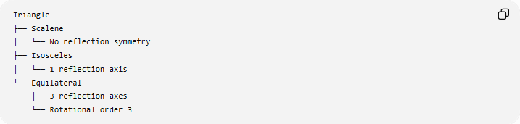
Triangle
├── Scalene
│ └── No reflection symmetry
├── Isosceles
│ └── 1 reflection axis
└── Equilateral
├── 3 reflection axes
└── Rotational order 3

17. Quadrilateral-Symmetry Conditions
# Source: AI Source: Provided by: [Data Path: Persons Table -> ID Column: 1, Name_En Column: Motasem Essam] -> From: [ChatGPT] on [7/25/2026]
Different quadrilaterals have different symmetry properties.
Rectangle
- 2 reflection axes
- rotational symmetry of order 2
Rhombus
- 2 reflection axes along its diagonals
- rotational symmetry of order 2
Square
- 4 reflection axes
- rotational symmetry of order 4
General Parallelogram
- generally no reflection symmetry
- rotational symmetry of order 2
Important
A parallelogram has central symmetry even though a general parallelogram does not have line symmetry.

18. Circle-Symmetry Conditions
# Source: AI Source: Provided by: [Data Path: Persons Table -> ID Column: 1, Name_En Column: Motasem Essam] -> From: [ChatGPT] on [7/25/2026]
A circle has extremely high symmetry.
A circle is symmetric about every line passing through its center.
It also has rotational symmetry through every angle:
$$\boxed{R_{θ}\left(C\right)=C}$$
for every rotation angle $θ$.
Example
For circle:
$$x^{2}+y^{2}=r^{2},$$
reflection across any line through the origin leaves the circle unchanged.

19. Plane-Symmetry Conditions
# Source: AI Source: Provided by: [Data Path: Persons Table -> ID Column: 1, Name_En Column: Motasem Essam] -> From: [ChatGPT] on [7/25/2026]
Definition
A Plane-Symmetry Condition occurs when a three-dimensional object is symmetric under reflection through a plane.
If $P$and $P^{'}$are corresponding points:
- the symmetry plane is perpendicular to $PP^{'}$,
- the plane bisects $PP^{'}$.
Example
A sphere has infinitely many planes of reflection symmetry, namely every plane passing through its center.

20. Spatial-Symmetry Conditions
# Source: AI Source: Provided by: [Data Path: Persons Table -> ID Column: 1, Name_En Column: Motasem Essam] -> From: [ChatGPT] on [7/25/2026]
Definition
Spatial-Symmetry Conditions concern symmetry of three-dimensional objects.
Possible symmetry transformations include:
- reflection in a plane,
- rotation about an axis,
- central inversion,
- rotational-reflection combinations.
Example
A cube has:
- multiple planes of reflection symmetry,
- multiple rotational symmetry axes,
- central symmetry.

21. Symmetric-Position Conditions
# Source: AI Source: Provided by: [Data Path: Persons Table -> ID Column: 1, Name_En Column: Motasem Essam] -> From: [ChatGPT] on [7/25/2026]
Definition
A Symmetric-Position Condition requires two or more points or objects to occupy corresponding positions relative to a symmetry element.
Example
If $A$and $B$are symmetric about line $l$, then:
$$l\text{ is the perpendicular bisector of }\overset{‾}{AB}.$$
Therefore:
$$AA^{'}⊥l$$
and:
$$MA=MA^{'}$$
where $M=AA^{'}∩l$.

22. Symmetry-Axis Conditions
# Source: AI Source: Provided by: [Data Path: Persons Table -> ID Column: 1, Name_En Column: Motasem Essam] -> From: [ChatGPT] on [7/25/2026]
Definition
A Symmetry-Axis Condition requires a particular line to be an axis of symmetry.
For a figure $F$:
$$\boxed{R_{l}\left(F\right)=F}.$$
Example
For the parabola:
$$y=x^{2},$$
the $y$-axis:
$$x=0$$
is its axis of symmetry.
Coordinate Test
Replacing:
$$x→-x$$
does not change:
$$y=x^{2}.$$

25. Symmetry-Center Conditions
# Source: AI Source: Provided by: [Data Path: Persons Table -> ID Column: 1, Name_En Column: Motasem Essam] -> From: [ChatGPT] on [7/25/2026]
Definition
A Symmetry-Center Condition requires a point to be the center of central symmetry.
For center $O$:
$$\boxed{O\text{ is the midpoint of every corresponding pair }PP^{'}}.$$
Example
The center of a parallelogram is the intersection of its diagonals.
If $O$is the center:
$$OA=OC$$
and:
$$OB=OD.$$

23. Symmetry-Order Conditions
# Source: AI Source: Provided by: [Data Path: Persons Table -> ID Column: 1, Name_En Column: Motasem Essam] -> From: [ChatGPT] on [7/25/2026]
Definition
A Symmetry-Order Condition specifies the number of times a figure maps onto itself during a full ${360}^{∘}$rotation.
For rotational symmetry of order $n$:
$$\boxed{θ_{min}=\frac{{360}^{∘}}{n}}.$$
Example
A regular hexagon has order:
$$n=6.$$
Therefore:
$$θ_{min}=\frac{{360}^{∘}}{6}={60}^{∘}.$$

24. Restricted-Symmetry Conditions
# Source: AI Source: Provided by: [Data Path: Persons Table -> ID Column: 1, Name_En Column: Motasem Essam] -> From: [ChatGPT] on [7/25/2026]
Definition
A Restricted-Symmetry Condition specifies symmetry only within a particular portion, region, or set of allowed transformations.
Example
A semicircle has reflection symmetry about the line perpendicular to its diameter through the center, but it does not have all the symmetries of the complete circle.
Another Example
A finite portion of a repeating pattern may exhibit reflection symmetry even though the complete infinite pattern has additional translational or glide symmetries.

25. Constructive Symmetry Conditions
# Source: AI Source: Provided by: [Data Path: Persons Table -> ID Column: 1, Name_En Column: Motasem Essam] -> From: [ChatGPT] on [7/25/2026]
Definition
A Constructive Symmetry Condition requires a geometric construction to create or preserve symmetry.
Example
To construct the reflection $A^{'}$of $A$across line $l$:
- Draw a perpendicular from $A$to $l$.
- Let the intersection be $M$.
- Mark $A^{'}$on the opposite side.
- Require:
$$MA=MA^{'}.$$
Then:
$$l$$
is the perpendicular bisector of:
$$\overset{‾}{AA^{'}}.$$

26. Symmetry-Based Locus Conditions
# Source: AI Source: Provided by: [Data Path: Persons Table -> ID Column: 1, Name_En Column: Motasem Essam] -> From: [ChatGPT] on [7/25/2026]
Definition
A Symmetry-Based Locus Condition uses symmetry to define a locus.
Example
The set of points equidistant from $A$and $B$:
$$PA=PB$$
is the perpendicular bisector of $\overset{‾}{AB}$.
This locus is itself a symmetry line:
$$\boxed{\text{Perpendicular Bisector}=\text{Reflection Axis exchanging }A\text{ and }B}.$$
Another Example
If $P$and $P^{'}$must be reflections about a fixed line $l$, their positions are constrained by:
$$PP^{'}⊥l$$
and:
$$d\left(P , l\right)=d\left(P^{'} , l\right).$$

27. Multiple-Symmetry Conditions
# Source: AI Source: Provided by: [Data Path: Persons Table -> ID Column: 1, Name_En Column: Motasem Essam] -> From: [ChatGPT] on [7/25/2026]
Definition
A Multiple-Symmetry Condition requires a figure to satisfy several symmetry conditions simultaneously.
Example
A square satisfies:
- reflection symmetry about its vertical axis,
- reflection symmetry about its horizontal axis,
- reflection symmetry about both diagonals,
- rotational symmetry of order $4$,
- point symmetry about its center.
Thus a single figure can satisfy many symmetry conditions.

28. Combined Symmetry Conditions
# Source: AI Source: Provided by: [Data Path: Persons Table -> ID Column: 1, Name_En Column: Motasem Essam] -> From: [ChatGPT] on [7/25/2026]
Definition
A Combined Symmetry Condition combines symmetry with another geometric condition.
Example
A point $P$may be required to:
$$P∈C$$
and to be symmetric to $Q$about line $l$.
Another example:
$$AB=AC$$
and
$$∠A={60}^{∘}.$$
Together, these conditions can identify an equilateral triangle, which has stronger symmetry than a general isosceles triangle.

Symmetry Conditions and Equality Conditions
# Source: AI Source: Provided by: [Data Path: Persons Table -> ID Column: 1, Name_En Column: Motasem Essam] -> From: [ChatGPT] on [7/25/2026]
Symmetry frequently produces equality conditions.
For reflection symmetry:
$$PA=PA^{'}$$
and corresponding lengths are equal.
For an isosceles triangle:
$$AB=AC$$
and:
$$∠B=∠C.$$
For a regular polygon:
$$AB=BC=CD=⋯$$
and corresponding angles are equal.
Thus:
$$\boxed{\text{Symmetry}→\text{Equal Corresponding Quantities}}$$
However, the converse is not always true: equality of some quantities does not necessarily establish complete symmetry.

Symmetry Conditions and Transformations
# Source: AI Source: Provided by: [Data Path: Persons Table -> ID Column: 1, Name_En Column: Motasem Essam] -> From: [ChatGPT] on [7/25/2026]
Symmetry is fundamentally transformation-based.
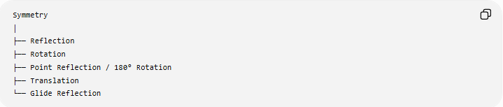
Symmetry
│
├── Reflection
├── Rotation
├── Point Reflection / 180° Rotation
├── Translation
└── Glide Reflection
A figure has a particular symmetry when the corresponding transformation maps the figure onto itself.
$$\boxed{T\left(F\right)=F}$$
where $T$is the relevant symmetry transformation.

Symmetry Conditions and Coordinates
# Source: AI Source: Provided by: [Data Path: Persons Table -> ID Column: 1, Name_En Column: Motasem Essam] -> From: [ChatGPT] on [7/25/2026]
Reflection Across the $x$-Axis
$$\left(x , y\right)→\left(x , -y\right).$$
Reflection Across the $y$-Axis
$$\left(x , y\right)→\left(- , xy\right).$$
Reflection Through the Origin
$$\left(x , y\right)→\left(- , x-y\right).$$
Reflection Across $y=x$
$$\left(x , y\right)→\left(y , x\right).$$
Central Symmetry About $\left(h , k\right)$
$$\boxed{\left(x , y\right)→\left(2 , h-x 2k-y\right)}$$
Example
For center:
$$O=\left(2 , 3\right),$$
the symmetric point of:
$$P=\left(5 , 7\right)$$
is:
$$P^{'}=\left(4 , -56-7\right)=\left(- , 1-1\right).$$

Symmetry Conditions and Loci
# Source: AI Source: Provided by: [Data Path: Persons Table -> ID Column: 1, Name_En Column: Motasem Essam] -> From: [ChatGPT] on [7/25/2026]
A symmetry condition can define or identify a locus.
For example:
$$PA=PB$$
defines the perpendicular bisector.
The perpendicular bisector is simultaneously:
- an equality-distance locus,
- a symmetry axis,
- a position condition,
- an incidence condition.
This illustrates the interconnected nature of geometric conditions.

Important Distinctions

Reflection Symmetry vs Rotational Symmetry
# Source: AI Source: Provided by: [Data Path: Persons Table -> ID Column: 1, Name_En Column: Motasem Essam] -> From: [ChatGPT] on [7/25/2026]
Reflection symmetry:
$$R_{l}\left(F\right)=F.$$
Rotational symmetry:
$$R_{θ}\left(F\right)=F.$$
A figure may have one without the other.

Point Symmetry vs Reflection Symmetry
# Source: AI Source: Provided by: [Data Path: Persons Table -> ID Column: 1, Name_En Column: Motasem Essam] -> From: [ChatGPT] on [7/25/2026]
Point symmetry uses a ${180}^{∘}$rotation about a point.
Reflection symmetry uses reflection across a line or plane.
A general parallelogram has point symmetry but generally no reflection symmetry.

Symmetry vs Equality
# Source: AI Source: Provided by: [Data Path: Persons Table -> ID Column: 1, Name_En Column: Motasem Essam] -> From: [ChatGPT] on [7/25/2026]
Symmetry often produces equality:
$$AB=AC,$$
but equality alone does not necessarily mean the entire figure is symmetric.

Symmetry vs Congruence
# Source: AI Source: Provided by: [Data Path: Persons Table -> ID Column: 1, Name_En Column: Motasem Essam] -> From: [ChatGPT] on [7/25/2026]
Reflection preserves congruence:
$$F≅R_{l}\left(F\right).$$
But two congruent figures do not necessarily form a symmetric pair unless their positions and correspondence satisfy the required symmetry transformation.

Classification Summary
# Source: AI Source: Provided by: [Data Path: Persons Table -> ID Column: 1, Name_En Column: Motasem Essam] -> From: [ChatGPT] on [7/25/2026]
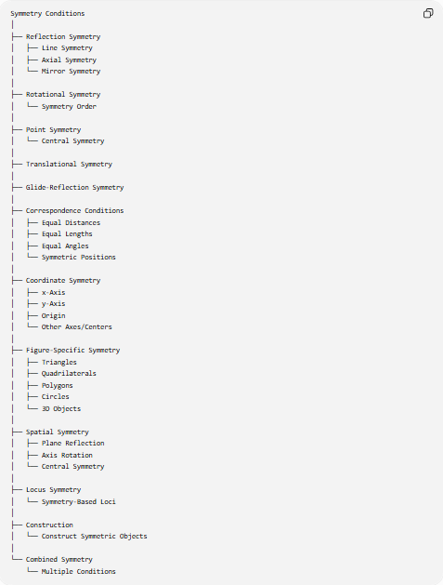
Symmetry Conditions
│
├── Reflection Symmetry
│ ├── Line Symmetry
│ ├── Axial Symmetry
│ └── Mirror Symmetry
│
├── Rotational Symmetry
│ └── Symmetry Order
│
├── Point Symmetry
│ └── Central Symmetry
│
├── Translational Symmetry
│
├── Glide-Reflection Symmetry
│
├── Correspondence Conditions
│ ├── Equal Distances
│ ├── Equal Lengths
│ ├── Equal Angles
│ └── Symmetric Positions
│
├── Coordinate Symmetry
│ ├── x-Axis
│ ├── y-Axis
│ ├── Origin
│ └── Other Axes/Centers
│
├── Figure-Specific Symmetry
│ ├── Triangles
│ ├── Quadrilaterals
│ ├── Polygons
│ ├── Circles
│ └── 3D Objects
│
├── Spatial Symmetry
│ ├── Plane Reflection
│ ├── Axis Rotation
│ └── Central Symmetry
│
├── Locus Symmetry
│ └── Symmetry-Based Loci
│
├── Construction
│ └── Construct Symmetric Objects
│
└── Combined Symmetry
└── Multiple Conditions

Key Formulas
# Source: AI Source: Provided by: [Data Path: Persons Table -> ID Column: 1, Name_En Column: Motasem Essam] -> From: [ChatGPT] on [7/25/2026]
Reflection Symmetry
$$\boxed{R_{l}\left(F\right)=F}$$
Rotational Symmetry
$$\boxed{R_{θ}\left(F\right)=F}$$
Rotational Order
$$\boxed{n=\frac{{360}^{∘}}{θ_{min}}}$$
Point Symmetry
$$\boxed{\vec{OP^{'}}=-\vec{OP}}$$
Reflection Across $x$-Axis
$$\boxed{\left(x , y\right)→\left(x , -y\right)}$$
Reflection Across $y$-Axis
$$\boxed{\left(x , y\right)→\left(- , xy\right)}$$
Central Symmetry About $\left(h , k\right)$
$$\boxed{\left(x , y\right)→\left(2 , h-x2k-y\right)}$$
Reflection-Pair Distance
If $P^{'}$is the reflection of $P$across $l$:
$$\boxed{d\left(P , l\right)=d\left(P^{'} , l\right)}$$
and:
$$\boxed{PP^{'}⊥l}.$$
Perpendicular-Bisector Symmetry
$$\boxed{PA=PB}$$
defines the perpendicular bisector of $\overset{‾}{AB}$.

Key Points
# Source: AI Source: Provided by: [Data Path: Persons Table -> ID Column: 1, Name_En Column: Motasem Essam] -> From: [ChatGPT] on [7/25/2026]
- Symmetry Conditions specify that a figure or configuration remains unchanged or corresponds to itself under a symmetry transformation.
- The fundamental transformation form is:
$$\boxed{T\left(F\right)=F}.$$
- Major symmetry types include:
  - reflection,
  - line/axial,
  - rotational,
  - point/central,
  - translational,
  - glide-reflection.
- Reflection symmetry is associated with a line or plane.
- Point symmetry is equivalent to ${180}^{∘}$rotational symmetry.
- A regular $n$-gon has:
$$n$$
reflection axes and rotational symmetry of order $n$.
- Symmetry often creates equal:
  - lengths,
  - distances,
  - angles,
  - areas.
- Symmetry can be expressed algebraically through coordinate transformations.
- Symmetry conditions are closely connected to:
  - equality conditions,
  - transformation conditions,
  - position conditions,
  - loci,
  - constructions,
  - congruence,
  - geometric proofs.

Conclusion
# Source: AI Source: Provided by: [Data Path: Persons Table -> ID Column: 1, Name_En Column: Motasem Essam] -> From: [ChatGPT] on [7/25/2026]
Symmetry Conditions specify geometric invariance or correspondence under transformations. Their central idea is that a transformation maps a figure or configuration back onto itself:
$$\boxed{T\left(F\right)=F}.$$
The major forms are:
$$\boxed{\text{Reflection} \text{Rotation} \text{Point/Central} \text{Translation} \text{Glide Reflection}}$$
Symmetry conditions are especially important because they connect several other types of geometric conditions:
$$\boxed{\text{Symmetry}→\text{Equalities}→\text{Positions}→\text{Transformations}→\text{Loci and Proofs}}$$
They provide a powerful way to describe the structure, balance, correspondence, and invariance of geometric figures and configurations.

